1. What goal will your website be designed to achieve?

The goal of this website is to allow users to search for local businesses such as restaurants, doctors, dentist, auto mechanic shops, etc. Users would then be able to share the business with their friends with a message to recommend the establishment or tell them to stay away. There will also be a tracker on the website that will keep track of all the user’s “liked” businesses.

|  |
| --- |
|  |

2. What kind of users will visit your site? In other words, what is the demographic of your users?

There isn’t a specific demographic that this website is going to target. Any users who are looking for recommendations or nearby businesses will be able to benefit from this website.

3. What data do you plan on using? You may have not picked your actual API yet, which is fine, just outline what kind of data you would like it to contain.

I plan on using the Yelp API which will allow me access to data to businesses. The search parameters I will be using will be term, location, and radius.

**This is taken from the Yelp API documentation**

|  |  |  |
| --- | --- | --- |
| term | string | Optional. Search term, for example "food" or "restaurants". The term may also be business names, such as "Starbucks". If term is not included the endpoint will default to searching across businesses from a small number of popular categories. |
| location | string | Required if either latitude or longitude is not provided. This string indicates the geographic area to be used when searching for businesses. Examples: "New York City", "NYC", "350 5th Ave, New York, NY 10118". Businesses returned in the response may not be strictly within the specified location. |
| radius | int | Optional. A suggested search radius in meters. This field is used as a suggestion to the search. The actual search radius may be lower than the suggested radius in dense urban areas, and higher in regions of less business density. If the specified value is too large, a AREA_TOO_LARGE error may be returned. The max value is 40000 meters (about 25 miles). |

4. In brief, outline your approach to creating your project (knowing that you may not know everything in advance and that these details might change later). Answer questions like the ones below, but feel free to add more information:

a. What does your database schema look like?

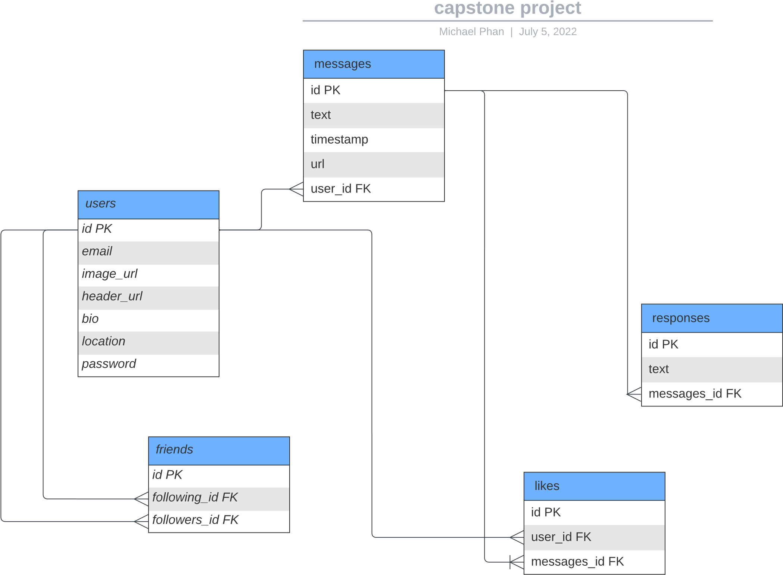

b. What kinds of issues might you run into with your API?

So far, the only issue that I can think of is there may be some type limitation on the usage of data since the API is free. Although I haven’t seen anything in the documentation that talks about limitations, I will be prepared for it.

c. Is there any sensitive information you need to secure?

The only sensitive information I will need to secure is user password which I’ll be using bcrypt to hash

d. What functionality will your app include?

Users will be able to search for search for local businesses such as restaurants, doctors, dentist, auto mechanic shops, etc. Users would then be able to share the business with their friends with a message to recommend the establishment or tell them to stay away. There will also be a tracker on the website that will keep track of all the user’s “liked” businesses.

e. What will the user flow look like?

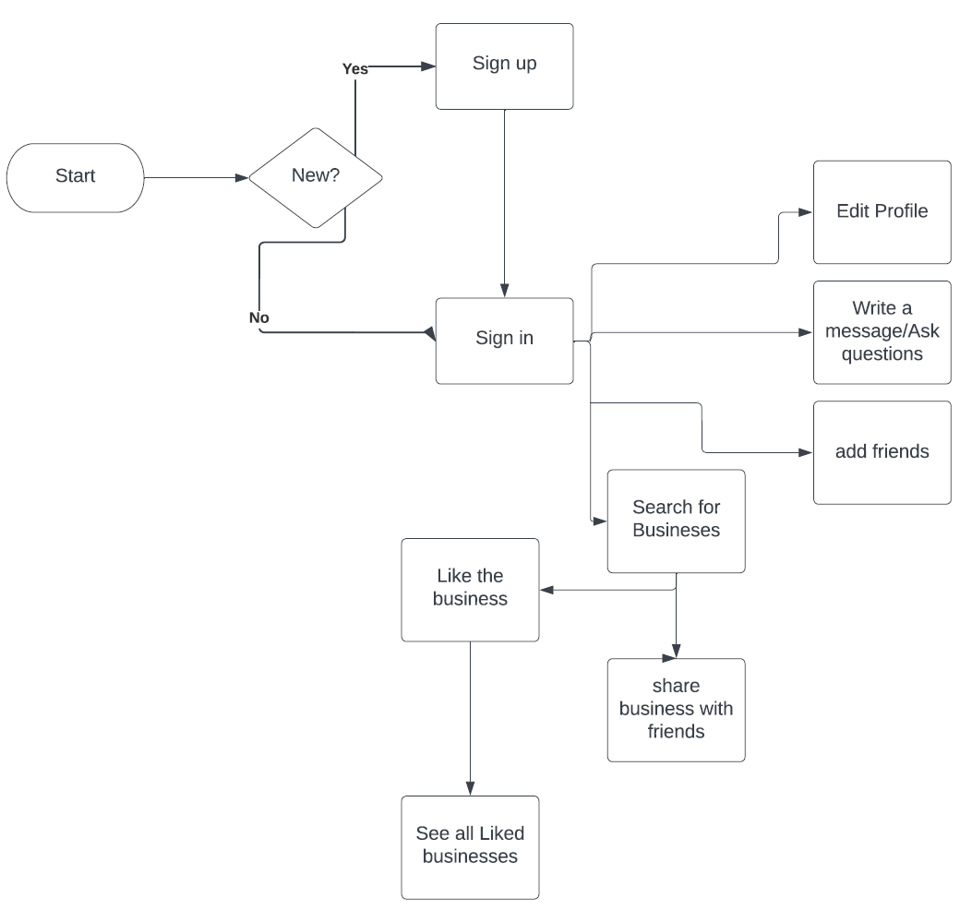

f. What features make your site more than CRUD?

This site will be interactive as users will be able to search for local businesses and share their findings with their friends. Another idea I had in mind is to allow users to share their food pictures in their profile and friends will be able to view and like it.